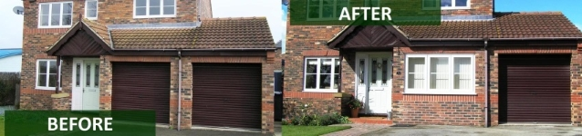

Garage Conversion
The following information is required for a permit application to be considered complete and able to be processed. Depending on the scope of work, some items may not apply or may be combined.
If you have a question on a required item, please contact the building department.
Read each item carefully and provide all applicable information.

How do I Apply?
Submit a completed application package to Adams County Building and Planning Department with the applicable fee.

Review Process and Timing
A Permit is issued once an application has been reviewed and approved by all applicable city departments. The time line for the review process varies depending on the size and scope of the project. Typically a garage conversion review is completed within two weeks after being submitted.

What information is required on the plans?
Construction Plans with information demonstrating how the new space will meet the following:
- 2015 International Residential Code
- 2015 Uniform Plumbing Code (if applicable)
- 2015 Washington State Energy Code (see attached for under slab insulation requirements)

The following information should be included on the construction plans:

(Min ¼” = 1 foot scale) (See examples attached)
- Floor plan showing existing space and proposed new space. (Indicate new window and door sizes; indicate use of space i.e. bedroom living room etc.)
- Floor framing (When not using existing garage slab floor.)
- Wall framing (Cross section detail)
- Garage door in-fill framing and footing
- Energy code compliance.
- Mechanical Equipment and location
- Whole house ventilation fan when area is over 500 square feet
- Site plan showing onsite parking (Min 1”= 20 feet)

Filling in the Garage Door Opening
- A continuous footing is required under the existing garage door opening. The construction detail attached is just one method. If others are proposed, submit the necessary construction details that meet compliance.

Energy Code
- The minimum prescriptive energy code shall meet the 2015 Washington State Energy Code. This form is part of the residential application package. If the minimum code cannot be met a component performance method (trade-off) can be used as an alternative approach to meet the energy code. The prescriptive and component method forms can be found at http://www.energy.wsu.edu/BuildingEfficiency/EnergyCode.aspx
- Min R-10 insulation shall be installed around the perimeter of conditioned (heated) space. See two approved methods for meeting this requirement attached to this handout.

Parking (Contact the City Planning Department for more information)
- A minimum of two on-site parking spaces are required for single family residences.
- Additional spaces may be required for accessory uses like accessory dwelling units.

Outside Air Ventilation
If the garage conversion is 500 square feet or greater, a whole-house ventilation system is required. Where bathrooms or kitchens are added to the space, a ventilation fan must be provided.

Existing Equipment Combustion Air
If existing fuel burning equipment is to remain in the converted garage space, combustion air shall be maintained. This can be accomplished by direct-vent appliances or construct a cold room for the appliance(s) while maintaining combustion air requirements. Other methods shall be considered.

Water Heater Pressure Relief
The pressure and temperature relief piping must be extended to the outside from the converted space. The pipe must terminate not more than 2’ or less than 6” from finished grade.

